Heaps and Heapsort
Definition of Heap:
A heap can be defined as a binary tree with keys assigned to its nodes (one key per node) provided the following two conditions are met:
      - The tree’s shape requirement – the binary tree is complete, that is, all its levels are full except possibly the last level, where only some rightmost leaves may be missing.
      - The parental dominance requirement – the key at each node is greater than or equal to the keys at its children.

Max-Heap − where the value of the root node is greater than or equal to either of its children.
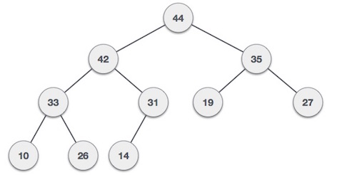
The tree given below is not a heap, because the tree’s shape requirement is violated.
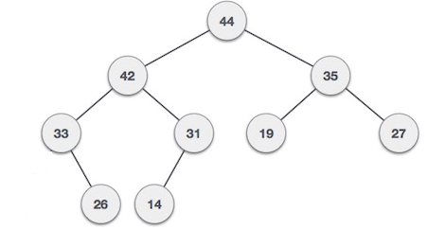
The tree given below is not a heap, because the tree’s parental dominance requirement is violated.
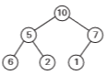

Heap and its array representation is shown below:
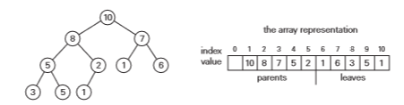
Properties of heaps:
1. There exists exactly one essentially complete binary tree with n nodes. Its height is equal to
2. The root of a heap always contains its largest element.
3. A node of a heap considered with all its descendants is also a heap.
4. A heap can be implemented as an array by recording its elements in the top-down, left-to-right fashion. It is convenient to store the heap’s element in positions 1 through n of such an array, leaving H[0] either unused or putting there a sentinel whose value is greater than every element in the heap. In such a representation,
a. the parental node keys will be in the first positions of the array, while the leaf keys will occupy the last positions.
b. the children of a key in the array’s parental position i will be in positions 2i and 2i+1, and, correspondingly, the parent of a key in position i (2 ≤ i ≤ n) will be in position .
Top-down construction of a heap for the list
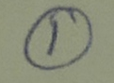
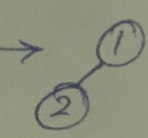
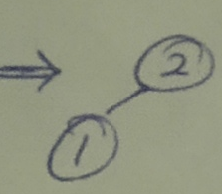
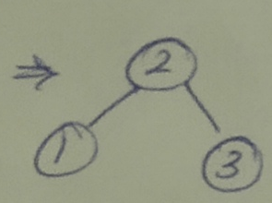
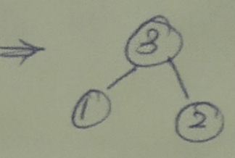
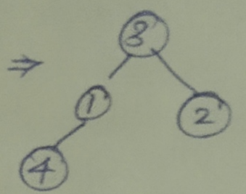
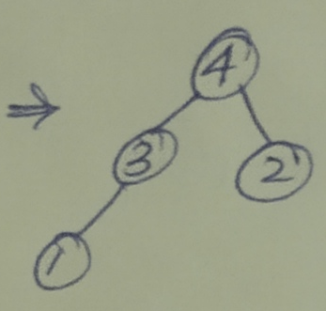
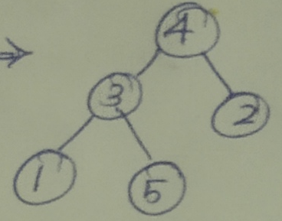
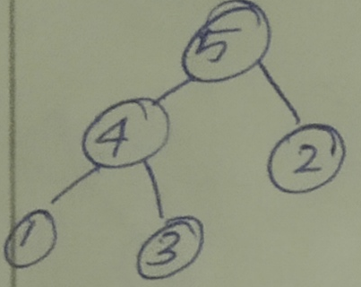
Bottom-up construction of a heap for the list 2, 9, 7, 6, 5, 8
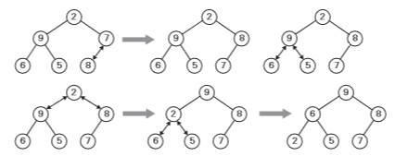
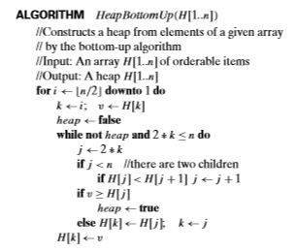
Inserting a key (10) into the heap constructed in the given figure. The new key is sifted up via a swap with its parent until it is not larger than its parent (or is in the root).
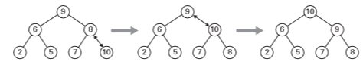

Maximum Key Deletion from a heap
Step 1 Exchange the root’s key with the last key K of the heap.
Step 2 Decrease the heap’s size by 1.
Step 3 “Heapify” the smaller tree by sifting K down the tree exactly in the same way we did it in the bottom-up heap construction algorithm. That is, verify the parental dominance for K: if it holds, we are done; if not, swap K with the larger of its children and repeat this operation until the parental dominance condition holds for K in its new position.
Example: Deleting the root’s key from a heap
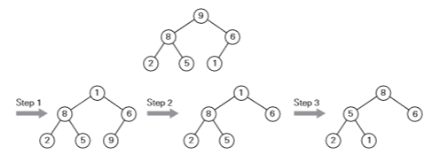
Heapsort
This is a two-stage algorithm that works as follows.
Stage1 (heap construction): Construct a heap for a given array.
Stage2 (maximum deletions): Apply the root-deletion operation n−1times to the remaining heap.
